**TASK 4**

**Building an E-Magazine/Online Newspaper Platform**

**OUTPUT:**

**HOME PAGE**

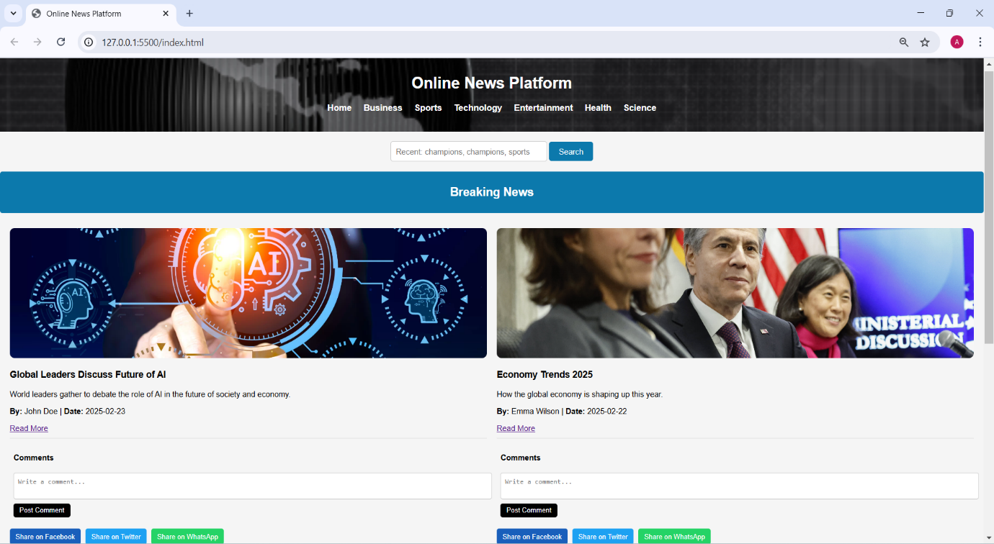

**BUSINESS NEWS**



**SPORTS NEWS**



**TECHNOLOGY NEWS**

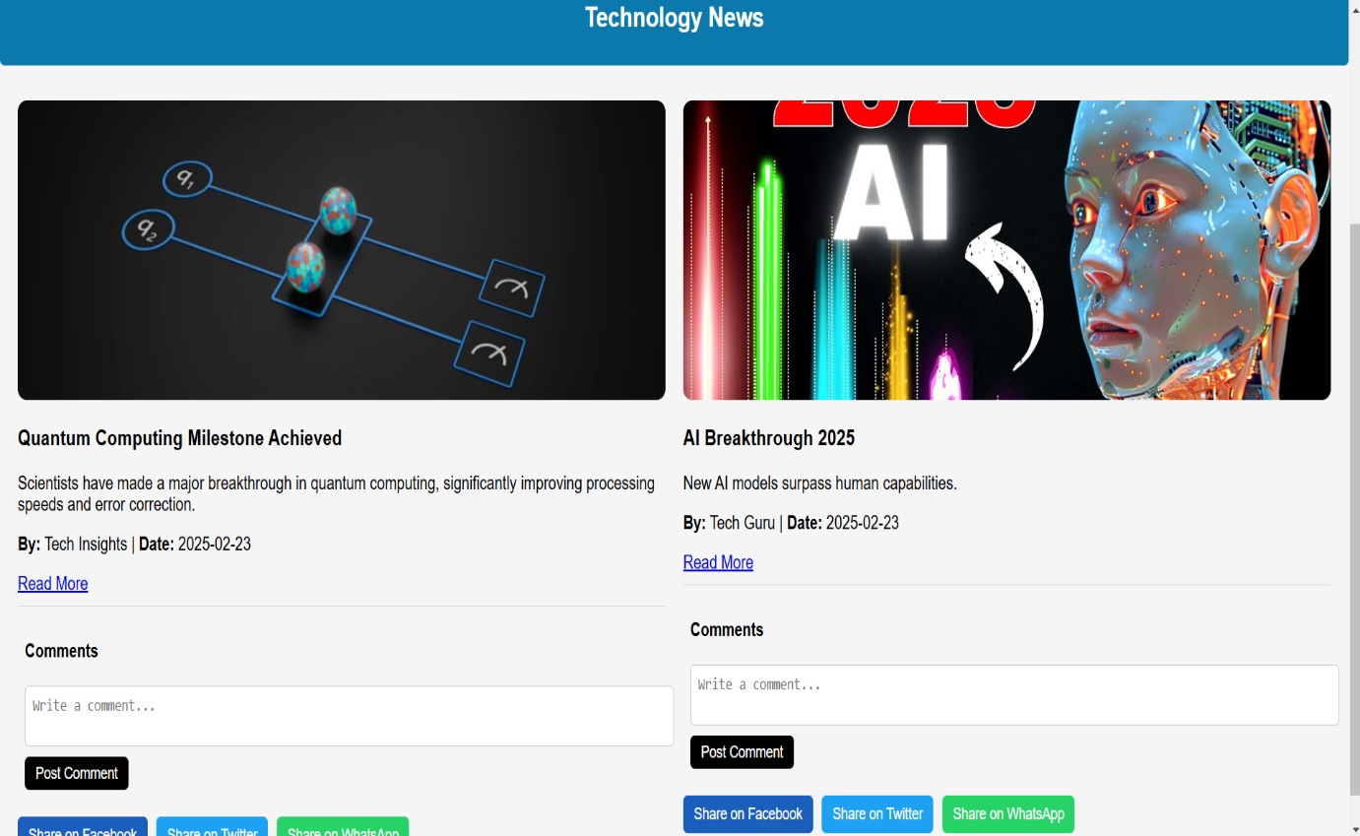

**ENTERTAINMENT NEWS**

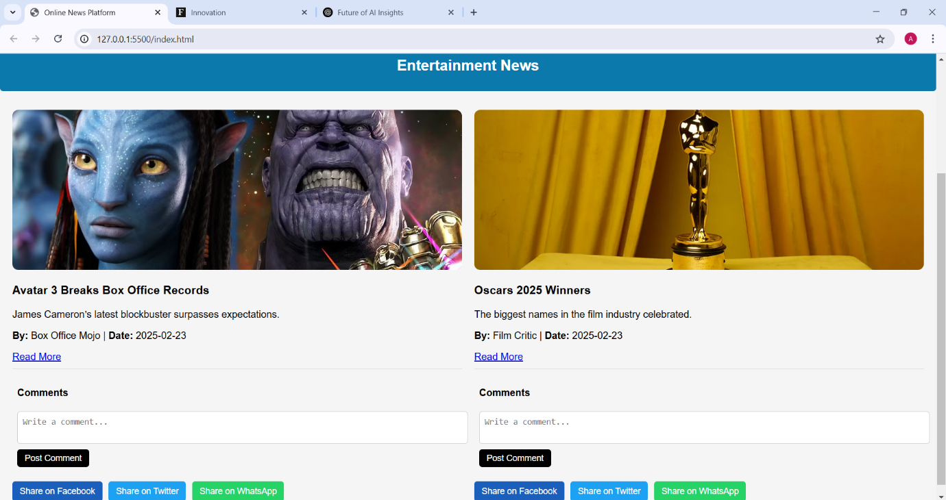

**HEALTH NEWS**

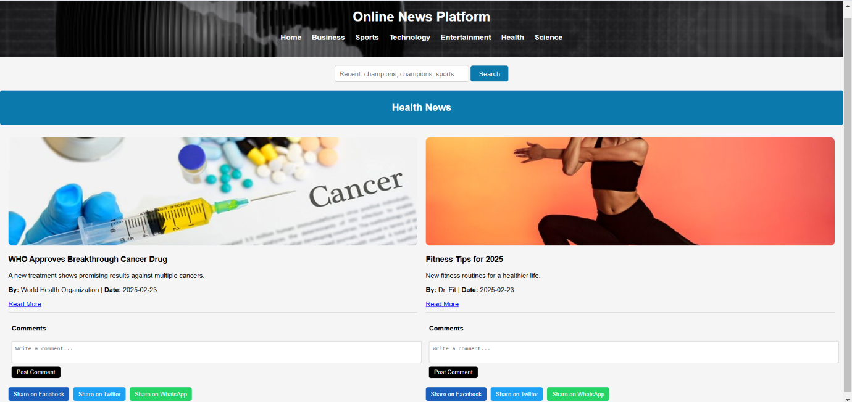

**SCIENCE NEWS**

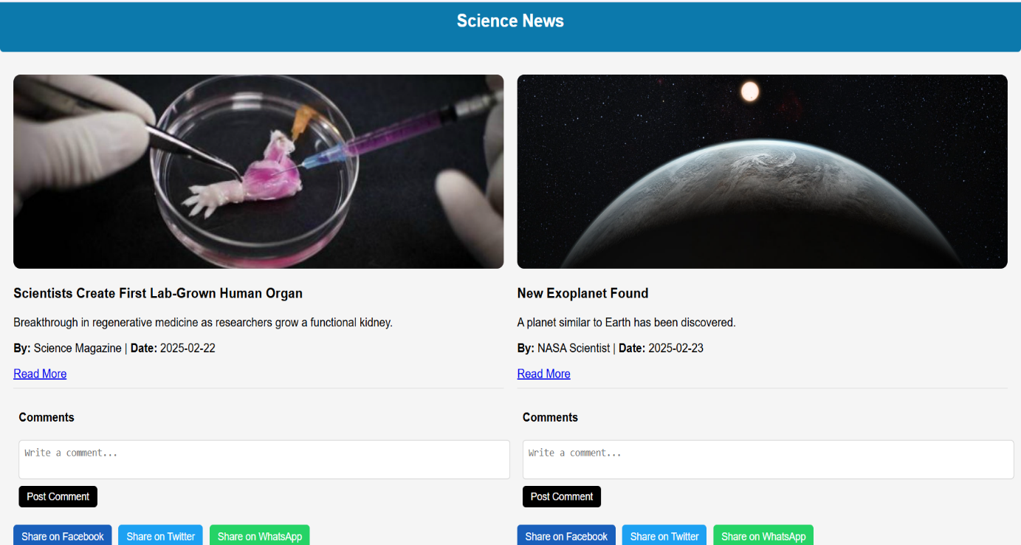

--------------------------------------------------------------------------------------------------------------------------

**NAVIGATION**

When a user clicks on a specific category, such as "Business," the platform dynamically updates the content to display relevant news articles from that category.



**SEARCH BAR**

The search bar allows users to filter and search articles based on keywords, including the article author. When a user enters an author's name, the platform dynamically updates the displayed articles to match the search criteria, making it easier to find relevant content.

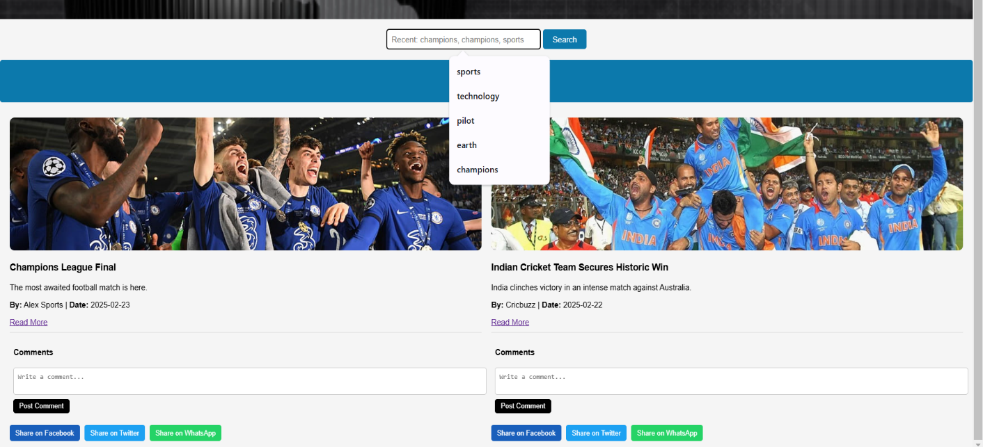

**SOCIAL SHARING**

The social sharing feature enables users to share news articles instantly on platforms like Facebook, Twitter, and WhatsApp. With a single click, users can distribute content to their network, increasing engagement and reach.



**COMMENT SECTION**

The comment section allows users to share their thoughts, opinions, and feedback on news articles. Users can type a comment, post it, and engage in discussions with others, enhancing interaction and community engagement on the platform**.**

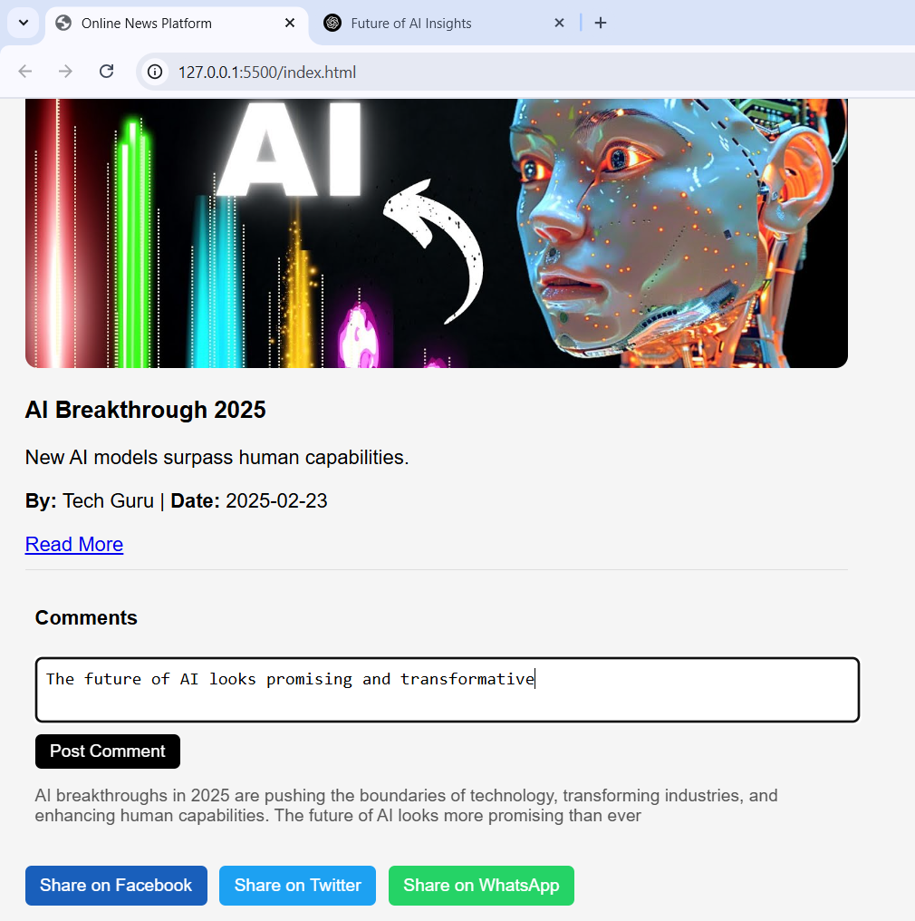

**READ MORE**

The **"Read More"** option allows users to view the full article by clicking on the link. Upon selection, the user is redirected to a new page or tab where the complete content is displayed.

